WRI 327 Final Project
Matthew Klump
7929 SW 40th Ave Apt A
Portland, OR 97219
(503) 293 7824

Report #######
November 28, 2001

Office of Congressmen Earl Blumenauer
516 SE Morrison
Suite 250
Portland, OR 97214
(503) 231-2300

Attention: Mr. Earl Blumenauer

REPORT REGARDING
FEDERAL FUNDING FOR EMBRYONIC STEM CELL RESEARCH

Mr. Blumenauer, the attached report discusses the facts and issues about embryonic stem cell research. It also talks about why it should be brought back to the Presidents desk for reconsideration of full federal funding for all legitimate instances of embryonic stem cell research. The most significant piece of evidence to support this recommendation is that we have barely revealed the possible cures currently afflicting mankind. Some examples I’m sure your aware of are Parkinson’s Disease and Alzheimer’s.
This report was authorized by Diane Chute of the Oregon Institute of Technology as a formal report writing project.
I must give big acknowledgement to my fiancé Jill Feyerherm for her help with the research, your always in my thoughts, and to the Instructors of the Speech 321 class I took at OIT for inspiring me to pick the subject matter.
I thank you Mr. Blumenauer for taking the time to review this report, and appreciation to you for the opportunity to prepare it.

Comments and thoughts are always welcome. Please direct them to my email address.
Sincerely,

Matthew J Klump
mklump@qwest.net
Citizen of the 3rd District of Oregon
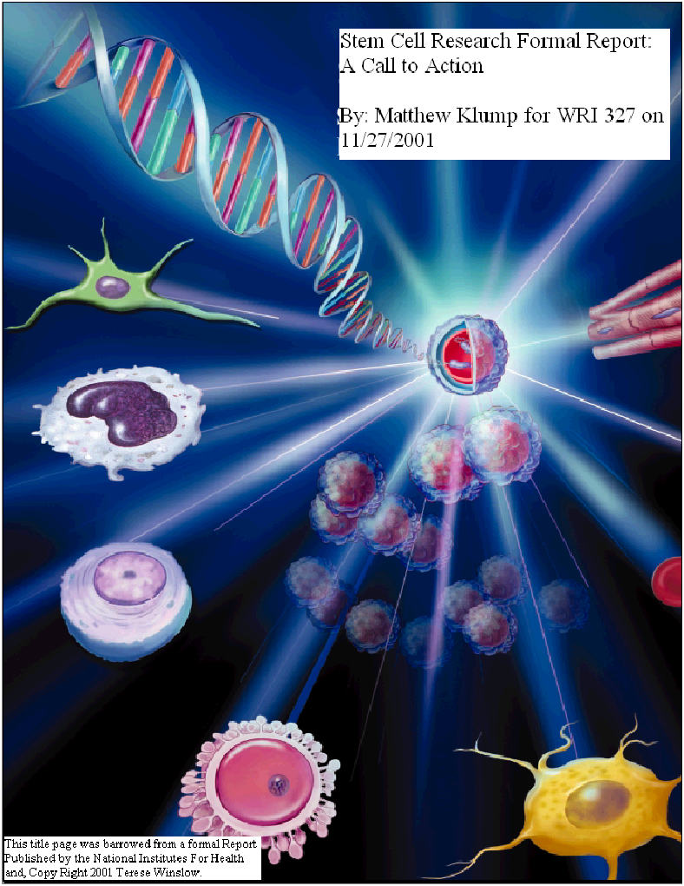

Table of Contents

Page
List of Illustrations . . . . . . . . . . . . . . . . . . . . . . . . . . . . . . . . . . . . . . . . . . 4

Executive Summary . . . . . . . . . . . . . . . . . . . . . . . . . . . . . . . . . . . . . . . . . 5

Introduction . . . . . . . . . . . . . . . . . . . . . . . . . . . . . . . . . . . . . . . . . . . . . . . 6

Facts About Stem Cell Research . . . . . . . . . . . . . . . . . . . . . . . . . . . . . . . 7

Presidential Guidelines for Federal Funding . . . . . . . . . . . . . . . . . . . . 10

Conclusions . . . . . . . . . . . . . . . . . . . . . . . . . . . . . . . . . . . . . . . . . . . . . . . 13

Recommendations . . . . . . . . . . . . . . . . . . . . . . . . . . . . . . . . . . . . . . . . . . 13

References . . . . . . . . . . . . . . . . . . . . . . . . . . . . . . . . . . . . . . . . . . . . . . . . 14

List of Illustrations

PAGE
Title Page Illustration . . . . . . . . . . . . . . . . . . . . . . . . . . . . . . . . . . . . . . . . 2
FIGURES
- Totipotent Stem Cell Potential . . . . . . . . . . . . . . . . . . . . . . . . . . . . . . . 7
- Development of Pluripotent Cells into Specialized, Multipotent Cells 8
- Examples of Pluripotent Stem Cell Development . . . . . . . . . . . . . . . . 9

Executive Summary

Mr. Blumenauer, we the people of the 3rd district of Oregon understand the fact that quite possibly the issue of abortion was more than likely the fuel for the debate of human cloning solely for the purpose of creating additional lines of embryonic stem cells for the purposes of research. Please understand that we know you are in favor of the research, and that you are non-biased and impartial when it comes to decision making. In response to the President’s speech delivered on August 9, 2001, we are writing this report to you to urge you to take action so that the President receives a clear message that the issue of federally funding Embryonic Stem Cell must be reconsidered. We feel this issue must be brought to bare before any other issue of health care because this research has the potential to produce numerous cures for today’s diseases.
Again we have only begun to scratch the surface of what this research can produce possible cures for. The number one underlining fact is that Embryonic Stem Cells maybe cultured to grow new replacement tissue to replace bad tissue. Private funding for research helps, but the research going on right now will progress much faster if full federal funding is empowered for all instances of Embryonic Stem Cell Research.

INTRODUCTION
On August 9, 2001, President George W. Bush established important guide lines for how federal funds would be allocated for Stem Cell Research. The purpose of this report is to convince you of the underlining importance of allowing full federal funding for all instances of Stem Cell Research. Mr. Blumenauer, what you have done up until this point is merely give a supporting role for the Advancement of Stem Cell Research. What we the people of the 3rd District of Oregon truly need is representation of this issue in Washington that drives the debate to the next level. Yes, other issues such as Terrorism and Abortion are important. However, because of all that is at stake in the advancement of human survival, this issue takes precedence over all else. We are relying on you, Congressmen Blumenauer, to spear head this problem to forefront of the President’s to do list just the same way he addressed Terrorism on America.

FACTS ABOUT STEM CELL RESEARCH

- What is a Stem Cell?
- Pluripotent Stem Cells Are the Key
- Possible Applications For Pluripotent Stem Cells
- There is no substitute for Pluripotent Stem Cells

PRESIDENTIAL GUIDE LINES FOR FEDERAL FUNDING
- Donor Consent
- Source of Embryos
- Induced Funding

The instances where no federal funding will be allowed:
- Creation of New Stem Cell Lines
- New Embryos For Research Purposes
- Cloning of Human Embryos

REPORT FORMAT

This report contains three main sections:

- About Stem Cell Research
- Presidential Guide Lines
- Conclusions and Recommendations

METHODS USED TO GATHER DATA
ABOUT STEM CELL RESEARCH
- I sent emails to both the office of Congressmen Earl Blumenauer and David Wu asking for their material on the subject.
- The internet provided me with a multitude of information on stem cells, including the National Institutes of Health, and other government websites.

Facts About Stem Cell Research
What is a Stem Cell?
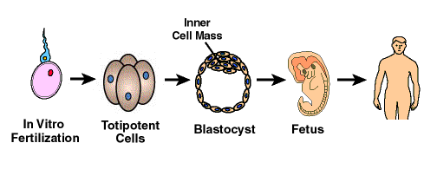
Stem cell have the ability to, when cultured under the correct conditions, replicate themselves into specific types of tissue. The definition of stem cells is best described in the context of what happens in the process of reproduction. When the sperm fertilizes the egg, the new fertilized egg becomes totipotent, which means that the fertilized egg has total potential to form into a fetus. Please see figure 1.

Figure 1: Totipotent Stem Cell Potential ¹

After about four days of cultured growth and after fertilization, the totipotent stem cells form hollow masses of cell clusters called blastocyst. The outer most layer of the blastocyst is hollow. Inside that cluster of cells is the inner cell mass.
This outer-most layer of cells continues developing onto form the placenta and other supporting tissue needed by the fetus to grow in the uterus. The inner most cells of the blastocyst will never have the ability to grow into a developing fetus. The outer-most cells have that responsibility. However, the inner cells due have the ability to form any tissue, organ, or extremity of the human body. It is because of this property that we call these cells pluripotent. Pluripotent cells give rise to many but not all the cells needed to grow into a fetus. In fact if pluripotent cells were used for the process of artificial insemination, the cells would never develop into a fetus. Pluripotent stem cells that, through cell division, become more discernable groups of cell types are called
multipotent. An example of a multipotent is a specific group of cells that form only red blood cells, white blood cells, and platelets. Please see figure 2.
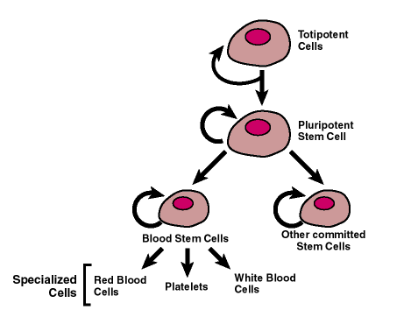

Figure 2: Development of Pluripotent Cells into Specialized, Multipotent Cells ²

Multipotent stem cells are also found in children and fully developed adults, not just the fetus. Take for example the most widely understood blood stem cell. The blood stem cells are found in the bone morrow of all children and adults, and in small traces inside the blood stream. This type of stem cell also plays a very important role in the replacement process of red blood cells, white blood cells, and platelets all through out our lives.
PLURIPOTENT STEM CELLS ARE THE KEY
One means to extract stem cells from the cell body while in the blastocyst stage is to isolate pluripotent stem cells directly from the inner cell mass of human embryo. The procedure for isolation requires intrusion inside to cell to extract the nucleus ultimately resulting in the death of the embryo. The last statement made is true for all methods used to extract stem cells. ³
Another means used to extract comparative pluripotent stem cells was performed by a physician who obtained informed consent from donors of physician deemed terminated pregnancies. The doctor extracted cells from the fetuses that were destined to form the tested and the ovaries. These cells when compared to the other stem cell taken from the embryo appeared to be extremely similar. ⁴
POSSIBLE APPLICATIONS FOR PURIPOTENT STEM CELLS
There is a multitude of facts that justify the isolation and extraction of pluripotent
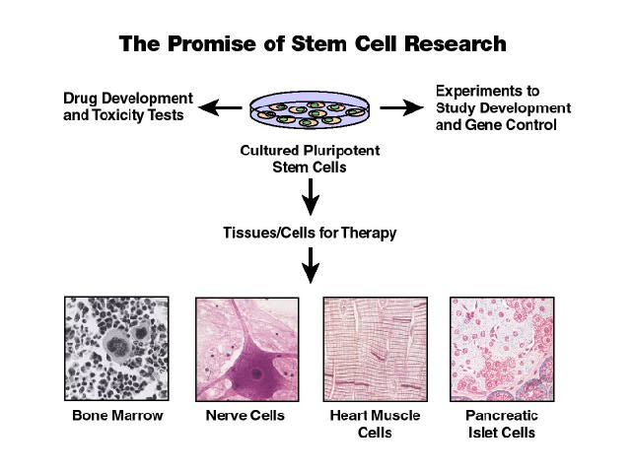
stem cells. The best way understand this is to first consider Figure 3: Examples of Pluripotent Stem Cell Development.

⁵ Figure 3: Examples of Pluripotent Stem Cell Development

At the most basic level of study, pluripotent stem cells have the ability to give us insight into human development. While more advanced forms of study will uncover pluripotent stem cells to replace (1) damaged or diseased bone marrow tissue (a cure for most blood diseases), (2) damaged of diseased nerve cells (a cure for Parkinson’s and Alzheimer’s Disease ), (3) damaged or diseased heart muscle tissue (a cure for stroke scar tissue), and (4) damaged or diseased pancreatic islet cell (a cure for Diabetes) just to name a few. The biggest of all of these being the transplantation of healthy heart muscle cells for people whose heart no longer pumps adequately.
THERE IS NO SUBSTITUTE FOR PLURIPOTENT STEM CELLS
It’s possible to cite for you, Congressmen, pages and pages of scientific fact supporting the nearly unlimited potential of Embryonic Pluripotent Stem Cells to grow replacement tissue for nearly any part of the human body. An example would be past research conducted on what you’ve heard to be Adult Stem Cells. That research proved that such cells will never incubate comparably to provide the most desirable replacement tissue.
Presidential Guidelines For Federal Funding: Mr. Blumenauer, this is the most important section of this formal report because federal funding is the back bone for all major scientific research. Please read this carefully regarding the President’s Guide Lines:
Donor Consent
Federal funding will only be allocated for existing stem cell lines acquired by the donor’s consent such as discarded material after an artificial insemination procedure.

SOURCE OF EMBRYOS
Research supported by federal funding on Stem Cells must be from excess embryos created solely for reproductive purposes.
INDUCED FUNDING
Federally supported Stem Cell research will not be allocated should the donor(s) of the Stem Cell Lines in question were financially induced by private interest.
Mr. Blumenauer, please support all of the above points accept for the policy established for the source of embryos. The idea that all resources useable to promote the further survivability of mankind is a strong argument for the President to reconsider. We need you to present this idea should you decide to confront the President with these facts.
The instances where no federal funding will be allowed:
Creation of New Stem Cell Lines
No federal funds will be used for the derivation or use of stem cell lines.
New Embryos For Research Purposes
No federal funds will be used for the creation of any human embryos for research purposes.
Cloning of Human Embryos
No federal funds will be used for the cloning of human embryos for any purpose.

CURRENTLY:
A scientific institution, of whom shall go unnamed in this report, has already violated the last two guidelines of federally funded research regarding cloning research of identical twins just this week (11/27/2001), and a Senate hearing is soon to be called into session to vote again on the cloning ban. Its important to us that you, Congressmen, put this issue on the lap of the President to bring about a higher level of acknowledgement. Innumerable facts prove that cloning human embryos for the purposes of Stem Cell research is an efficient, nearly red-tape free way to get stem cells. Because of the above arguments Mr. Congressmen, artificial Stem Cells must be reconsidered for funding by the President.

CONCLUSIONS
The research done this far on Embryonic Pluripotent Stem Cells revealed a great deal of promise in the way of potential cures for a the vast majority of debilitating diseases we’ve diagnosed in America today. We also now know that there is exactly zero substitutes for what Embryonic Stem Cells can potentially provide us, and that inhibiting the progress of this research is not the best choice at this time.
We have seen, from previous research success, that federal funding is likely the substance of real progress for Embryonic Stem Cell Research. We have to rely on you and the other branches of government to drive this issue to the very top of the President’s domestic to-do list. Other issues such as foreign policy have extreme relevance today because of what happened last September, but regarding the issues of domestic health care, this has greater priority of all due to what’s at stake.

RECOMMENDATIONS

- Reacquaint the President with the facts about Stem Cell Research.
- Have the President reconsider his position on the matter of guidelines for federal funding of embryonic stem cell research.
- Call a new vote before the house of representatives on the matter of the banning of human cloning due to the fact of recent developments of natural identical twin cloning research.

REFERENCES

- 3. 4.National Institutes Of Health. Office of the Director. [online] (2001). Available via the Internet: http://www.nih.gov/news/stemcell. Accessed, 2001 November 8.

- White House. Office of President George W. Bush. [online] (2001). Available via the Internet: http://www.whitehouse.gov/news/2001. Accessed, 2001 November 13.

- The House of Representatives. Office of Congressmen Earl Blumenauer. [online] (2001). Available via the Internet: http://www.house.gov/blumenauer/floor_speeches. Accessed, 2001 November 14.

- California Healthcare Institutes. Office of David Gollaher President and CEO. [online] (2001). Available via the Internet: http://www.chi.org. Accessed, 2001 November 15.

